**MDF Rose Engine Lathe 2.0**

**with Stepper Motor Drive**

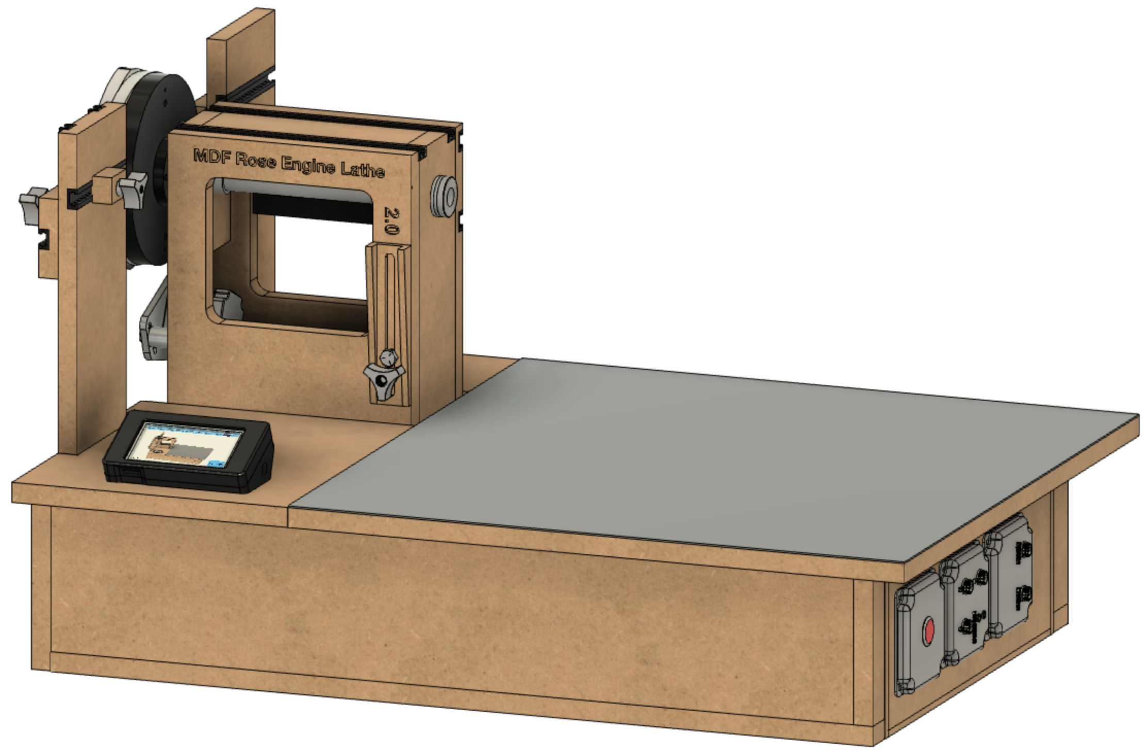

**Instructions for Building the**

**Stepper Controls**

**Version 0.1**

**30 July 2020**

This document is intended to help one unfamiliar with the MDF rose engine to build one easily. It is designed to go with the kit you can purchase from [www.ColvinTools.com](http://www.ColvinTools.com).

There are some variations from the ideas documented by Jon Magill at [www.rogueturner.com](http://www.rogueturner.com/). Where this is the case, we have tried to document such changes and provide the reason for the change.

This document is also designed to use a stepper motor for driving the spindle.

If you have any questions, please contact us at [ColvinTools@Gmail.com](mailto:ColvinTools@Gmail.com).

Good luck.

Rich Colvin & Jack Zimmel

Table of Contents

Getting Started 4

Parts List 5

PCB - Rose Engine Controller Spindle and Three Axes V002C 6

Through-Hole Components, part 1 6

Headers for Integrated Circuits 7

Through-Hole Components, part 2 8

Cabling 9

# Getting Started

As you get started with building this machine, please consider making the machine exactly according to the outlined instructions. There are lots of ways you can modify this, and, quite frankly, the MDF rose engine encourages experimentation. But it is best to attempt those modifications after understanding how it works. Some ideas which sound grand may not appear so after understanding how the machine works (we speak from experience).

If you have any questions on the terminology in this document, check out the “Ornamental Turning Book of Knowledge” ([www.OTBoK.info](https://www.otbok.info/)).

This document outlines the approach for wiring this machine using:

* Rose Engine Controller Spindle and Three Axes V002c
* DM542T Stepper Motor Drivers
* Nextion HMI Display, model NX4827K043

Cabling standards are outlined in the companion document.

# Parts List

|  |  |  |  |  |
| --- | --- | --- | --- | --- |
| Item | Item | Qty | Source | Source P/N |
| 1 | AC/DC Power Supply - LRS-100-24 | 1 | Digi-Key | 1866-3314-ND |
| 2 | Printed Circuit Board (PCB) | 1 | OSH Park | 4Rose_002c_Gerbers copy |
| 3 | Header Sockets | 1 | Digi-Key | HDR100IMP40F-G-V-TH-ND |
| 4 | 20-pin DIP sockets | 2 | Digi-Key | ED3054-5-ND |
| 5 | 10 KΩ resistors | 8 | Digi-Key | CF14JT10K0CT-ND |
| 6 | 100 µF Capacitor | 1 | Digi-Key | PCE3898CT-ND |
| 7 | 74HCT245 ( | 2 | Digi-Key | 296-1612-5-ND |
| 8 | R-78E5.0-1.0 (DC DC Converter) | 1 | Digi-Key | 945-2201-ND |

# PCB - Rose Engine Controller Spindle and Three Axes V002C

## Through-Hole Components, part 1

Solder in the components noted below.

10 KΩ resistors (8)

## Headers for Integrated Circuits

Solder in the 6 headers for integrated circuits. These should be 2.54mm female headers.

Headers (2) for Teensy 3.5

20-pin DIP sockets (2) for 74HCT245s

## Through-Hole Components, part 2

Solder in the components noted below.

100 µF Capacitor

R-78E5.0-1.0 DC DC Converter

## Cabling

Solder in the cables noted below.

**Cabling for 24 VDC Power Feed**

|  |  |
| --- | --- |
| ⭘ GND | White |
| ⭘ +24V | Red |
| 22 AWG / 2 | |

**Cabling for DM542T Drivers (4)**

(same for B, X, & Z)

|  |  |
| --- | --- |
| ⭘ GND | White |
| ⭘ DIR | Red |
| ⭘ STEP/PUL | Black |
| 🞎 ENA | Yellow |
| Enable is square & closest to the J6 / J31 / J32 / J33 label | |
| 20 AWG / 4 - Stranded | |

**Cabling for Nextion Display**

|  |  |
| --- | --- |
| ⭘ Tx | White/Orange |
| ⭘ Rx | White/Green |
| ⭘ GND | Orange |
| 🞎 +5V | Green |
| +5V is closest to the J20 label. | |
| Cat-5 or higher | |

**Cabling for Limit Switches (2)**

|  |  |
| --- | --- |
| ⭘ GND | White |
| ⭘ +3.3V | Red |
| Pins 34 & 35 | |
| 22 AWG / 2 - Stranded | |

To the extent that material may appear to be infringed, we assert that such alleged infringement is permissible under fair use principles in U.S. copyright laws. If you believe material has been used in an unauthorized manner, please contact me at [ColvinTools@Gmail.com](mailto:ColvinTools@Gmail.com).

The layout of the Printed Circuit Board (PCB) is copyright Ed French and is used with his permission.